Brief information about the project
URN and project name: | AP08855976 "Early Metal Age of the North-Eastern Regions of Central Kazakhstan"
Implementation Timeline: | 01.10.2021-31.12.2022
Relevance: | The project is aimed at studying the Early Metal Age objects of the north-eastern regions of Central Kazakhstan and is the first stage in the formation of the source base of a separate part of the vast steppe region. The obtained material will become the foundation for a step-by-step study of the Early Metal Age of the whole Central Kazakhstan.
Objective: | Finding out the ethno-cultural situation, determining the significance of cultural formations of the north-eastern regions of Central Kazakhstan among the synchronous cultural formations of Northern Eurasia in the Early Metal Age (III - early II millennium BC).
Expected and achieved results: | 1. Collecting all available information on Early Metal Age monuments and chance finds, as well as identifying new basic archaeological sites. Formation of a well-documented corpus of sources. Identification of new basic archaeological sites.  2. characterization of material culture of the Early Metal Age of the region (definition of ceramic traditions, characterization of stone industry, metal complex and metallurgy, art, economy).  3. Determination of cultural affiliation and chronology of archaeological monuments of the Early Metal Age, the presence of kinship or lack thereof between them. Determination of distribution areas of the identified cultural formations of the region.  4. Consideration of the issues of genesis, interrelations of the ancient population on the designated territory, revealing the role of migration, assimilation, cultural innovations and traditions in these processes.  Results achieved  1) all available information on early metal monuments of northeastern regions of Central Kazakhstan, including information on 28 archaeological sites and 11 accidental finds of various artifacts was supplemented; 2) new monuments were discovered, field studies were carried out, as a result of which material for natural science research was obtained; 3) research results were partially presented to the scientific community.  1. Vartholomeev V.V., Mertz V.K., Mertz I.V. Shokpartas - a new Eneolithic monument of the Central Saryarka // Bulletin of L.N. Gumilyov Eurasian National University. Series Historical Sciences. Philosophy. Religious Studies. № 1(134). 2021. С.36-48.  2. Mertz I.V. Afanasievskie monuments of Eastern Kazakhstan // Archaeological monuments of South Siberia and Central Asia: from the emergence of the first pastoralists to the era of the formation of state formations: Proceedings of the International Scientific Conference dedicated to the 85th anniversary of Dr. Elga Borisovna Vadetskaya (1936-2018) and the 90th anniversary of Dr. Gleb Alekseevich Maksimenkov (1930-1986) (April 19-21, 2021), St. Petersburg) / edited by A. V. Polyakov, N. Y. Smirnov. - St. Petersburg: IIMK RAS, 2021. С. 39-42.  3. Merts I.V., Kukushkin I.A., Dmitriev E.A. Senkibay-2 - a new location of Elunin ceramics in Central Saryarka // Preservation and study of the cultural heritage of the Altai Krai: collection of scientific articles. - Barnaul: Publisher Alt. Usta. - issue XXVII. - P. 232-237.  4. Grushin S.P., Mertz I.V., Mertz V.K., Fribus A.V., Ilyushina V.A. Burial complex of the Middle Bronze Age burial ground Semiyarka IV (East Kazakhstan) // Bulletin of Archaeology, Anthropology and Ethnography. 2021. № 2 (53). С. 52-65.  5. Stepanova N.F., Mertz I.V. New about local variants of the Afanasyev cultural-historical community// Cultures of the Asian part of Eurasia in antiquity and the Middle Ages. Proceedings of the International Scientific Conference devoted to the 80th anniversary of the birth and 50th anniversary of scientific and pedagogical activity of Prof. Nona Armaisovna Avanesova. Samarkand: SGU, 2021. С. 259-263.  6. Mertz I.V., Rogozhinsky A.E. Andronovo settlement of Elike sazy in Tarbagatai // Orazbayev Readings XIII. Almaty, 2021. С. 23-27.  7. Svyatko S.V., Reimer P.J., Schulting R., Shevnina I., Logvin A., Voyakin D.A., Stobbe A., Stepanova N.F, Merts I.V., Varfolomeev V.V., Soenov V., Tsydenova N., Kovtun I. Freshwater Reservoir Effects in Archaeological Contexts of Siberia and the Eurasian Steppe // Radiocarbon on reviewing  8. Pablo Librado, ... Merts V., Merts I., ... , Ludovic Orlando the origins and spread of domestic horses from the Western Eurasian steppes // Nature. October 20, 2021. https://doi.org/10.1038/s41586-021-04018-9
Composition of the research team
 | Ilya Viktorovich Merts
 | Scientific supervisor of the project
 | Date of birth: 22.11.1987
 | Candidate of Historical Sciences
 | Researcher of the Center for Archaeological Research named after Margulan. Margulan Center for Archaeological Research, Toraighyrov University NJSC
 | His research interests include the archaeology of the Bronze Age of Northern Eurasia, in particular the problems of cultural genesis, pottery, the formation of metallurgy and mining in the Bronze Age.
 | Researcher ID* W-2579-2017 https://publons.com/researcher/1993644/ilja-ivm-merts/
 | Scopus Author ID* 56866320100 https://www.scopus.com/authid/detail.uri?authorId=56866320100
 | ORCID* 0000-0001-9066-9629 https://orcid.org/0000-0001-9066-9629
Author of 30 scientific works published in scientific editions of Kazakhstan and Russia. Participant of a number of research projects of the Russian Foundation for Scientific Research and the Ministry of Science and Education of the Republic of Kazakhstan, as well as complex archaeological expeditions in Kazakhstan, Mongolia and Russia.
Articles in the publication included in the Skopus list:
1) Gaunitz Ch., ...V. Merz, Merz I., ...Orlando L. Ancient genomes revisit the ancestry of domestic and Przewalski's horses // Science. Vol. 360. Issue 6384. PP. 111-114. http://science.sciencemag.org/content/early/2018/02/21/science.aao3297
2) de Barros Damgaard P., ... Merz V., Merz I... ..., Durbin R. The first horse herders and the impact of early Bronze Age steppe expansions into Asia // Science. Vol. 360. Issue 6396.http://science.sciencemag.org/content/early/2018/05/08/science.aar7711
3) de Barros Damgaard P., ... Mertz I. V., Mertz V. K., ...Willerslev E.137 ancient human genomes from across the Eurasian steppes // Nature (2018) https://doi.org/10.1038/s41586-018-0094-2
4) Librado, P., Khan, N., Fages A., ...Outram A., Orlando L. The origins and spread of domestic horses from the Western Eurasian steppes
Nature, 2021, 598(7882), pp. 634-640
99th percentile https://www.scopus.com/sourceid/21206#tabs=1
Articles in publications included in the list of Committee for Quality Assurance in the Sphere of Education of the Ministry of Education of the Republic of Kazakhstan:
1) Omarov G.K., Besetaev B.B., Mertz I.V., Sagyndykova S.T. Brief report on the results of archaeological survey in the territory of Kurchum district in 2018 // Bulletin of Al-Farabi Kazakh National University. Series historical. № 4 (91). 2018.С. 201-213.
2) Merts I.V. The most ancient, wheeled transportation of East Kazakhstan. //Electronic scientific journal "edu.e-history.kz"
http://edu.e-history.kz/kz/publications/view/1029.
3) Merts I.V., Antonov M.A. Enbek Grotto with rock paintings in the vicinity of Taldykorgan // Otantarikhi, No. 2 (86), 2019. С. 200-214.
4) Vartholomeev V.V., Mertz V.K., Mertz I.V. Shokpartas - a new Eneolithic monument of the Central Saryarka // VESTRIC of L.N. Gumilyov Eurasian National University. Series Historical Sciences. Philosophy. Religious Studies. № 1(134). 2021. С.36-48.; DOI: https://doi.org/10.32523/2616-7255-2021-134-1-36-48
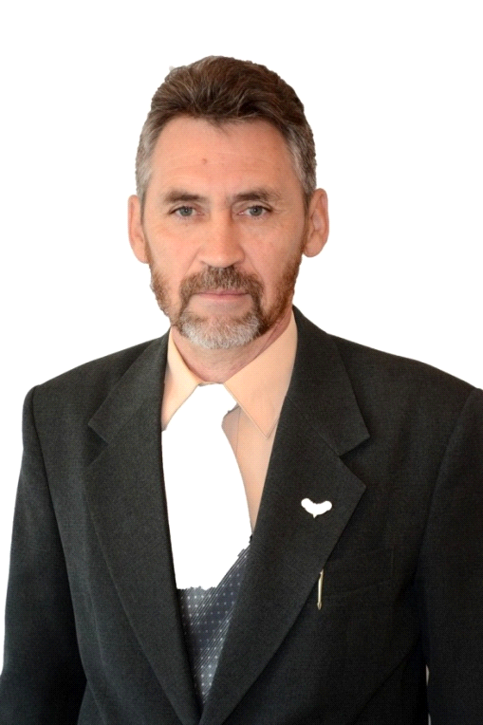 | Mertz Viktor Karlovich
 | Research Associate
 | Date of Birth: 30.11.1962
 | Candidate of Historical Sciences, Professor
 | Director of the Center for Archaeological Research named after Margulan. Margulan Center for Archaeological Research, Toraighyrov University NJSC
 | Research interests: Stone Age and primitive archaeology in general, problems of anthropogenesis and cultural genesis, origin of art.
Researcher ID* O-1119-2019
https://publons.com/researcher/2921917/viktor-k-merts/
Scopus Author ID* 57200799329
https://www.scopus.com/authid/detail.uri?authorId=57200799329
ORCID* 0000-0003-3163-1609
https://orcid.org/0000-0003-3163-1609
Main scientific achievements: For more than thirty years conducts independent archaeological research on topics related to the ideas of the project, the author and co-author of more than 100 works on the archaeology of Kazakhstan. One of the authors and compilers of the "Code of monuments of Pavlodar region", which includes information about more than 600 monuments of archeology of different periods. Results of scientific activity are reflected in a number of publications. Hirsch index 5. He is the largest domestic specialist in the field of archeology of the Stone Age and transitional from the Stone Age to the Bronze Age period.
Articles in the publication included in the Skopus list:
1) Gaunitz Ch., ...V. Merz, Merz I., ...Orlando L. Ancient genomes revisit the ancestry of domestic and Przewalski's horses // Science. Vol. 360. Issue 6384. PP. 111-114. http://science.sciencemag.org/content/early/2018/02/21/science.aao3297
2) de Barros Damgaard P., ... Merz V., Merz I... ..., Durbin R. The first horse herders and the impact of early Bronze Age steppe expansions into Asia // Science. Vol. 360. Issue 6396.http://science.sciencemag.org/content/early/2018/05/08/science.aar7711
3) de Barros Damgaard P., ... Mertz I. V., Mertz V. K., ...Willerslev E.137 ancient human genomes from across the Eurasian steppes // Nature (2018) https://doi.org/10.1038/s41586-018-0094-2
4) Műhlemann B., ...Merz V., ...Willerslev E. Ancient hepatitis B viruses from the Bronze Age to the Medieval period // Nature (2018) https://doi.org/10.1038/s41586-018-0097-z
5) Pablo Librado, ... Merts V., Merts I., ..., Ludovic Orlando the origins and spread of domestic horses from the Western Eurasian steppes // Nature. October 20, 2021. https://doi.org/10.1038/s41586-021-04018-9
Monographs:
1) Merts V. K. A brief history of the development of material culture of Pavlodar Priirtyshye: illustrated popular science edition. Pavlodar, 2019. 142 с.
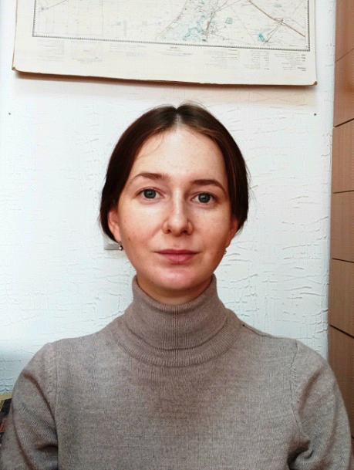 | Lyalina (Demidkova) Elena Danilovna
 | Laboratory technician
 | Date of birth: 03.05.1996
 | Master of Archaeology and Ethnology
 | Researcher of the Center for Archaeological Research named after Margulan. Margulan Center for Archaeological Research, Toraighyrov University NJSC
 | Area of expertise: archaeology
More than 10 scientific publications, including the most significant ones:
1) Comparative analysis of stone industry of Kostomar settlement and Chernoozerie VIa site // Proceedings of the Russian (with international participation) archaeological and ethnographic conference of students, undergraduates, graduate students and young scientists (RAESK-58), Omsk, 2018.
2) On specifying the location of some archaeological monuments of Pavlodar Priirtysh // Materials of the Republican scientific and practical conference "historical science" Rukhani zhangyru " in memory of Doctor of historical sciences, professor Kadysova Roza Zhumabayevna / PSU named after S. Toraighyrov. - Pavlodar, 2018. - VOL. 2. - P. 271-274.
3) Archaeological research in the mountains Kalmakkyrgan (Mayskiy district of Pavlodar region)/ Merts V.K., Merts I.V. // Margulanovskie readings - 2020: materials of the international scientific-practical conference "The Great Steppe in the light of archaeological and interdisciplinary studies" (Almaty, September 17-18, 2020). Almaty: Institute of Archaeology named after A.H. Margulan. A.H. Margulan, 2020. Т. 2. С. 483-497.
 | Nadezhda Volkova
 | Junior researcher
 | Date of birth: 08.01.1970
 | Master of Pedagogical Sciences, specializing in pedagogy and psychology
 | Researcher of the Center for Archaeological Research named after Margulan. Margulan Center for Archaeological Research, Toraighyrov University NJSC
 | Research interests design, art, photography, ceramics, archaeological drawing
 | Member of the Eurasian Union of Designers and the Union of Designers of Irtysh Land.

